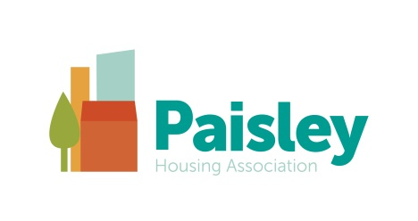
Feedback on our Rent & Service Charges Consultation 2021.22

We would like to thank all of our tenants who gave their views on our proposed rent and service charge for 2021.22. This year we sent out our consultation electronically via email, (where we had our tenants email contact details) and posted out the rest.

Our proposed rent increase for each property was dependent on whether its rent was at its target rent or not. For those at target rent we were proposing a 0% increase and for those not at target rent we were proposing to only apply the phasing for year 6 of the 10 year phasing required to get its rent to its target rent.

In addition to seeking views on the proposed rents we also sought views on the service charges that applied to each tenancy.

In total we received 88 responses. This is our lowest return for a long time but we expected this given that the only increase proposed for rents was solely limited to the phasing required for properties which are not at target rent.

Of the 88 tenants who gave their views, 49 live in properties where their rents are at target and 39 tenants live in properties where their rents are not at target rent.

Of those at target rent 42 agreed with the proposal and 7 disagreed.

Of those tenants not at target rent 23 agreed with the proposal, 1 had no opinion and 15 disagreed.

Some tenants who disagreed with the proposals gave comments and these ranged from not being able to afford the increase proposed, to concern over the standard and value for money for the services they receive, particularly the close cleaning service.

These comments formed part of the report which went to our Board for consideration and have highlighted the ongoing need for our Advice Services which helps our tenants to maximise their incomes while they face challenging times.

It has also made us question our services and how we can going forward ensure that the contractor is delivering our standard of specification. During the pandemic this has been challenging as staff who monitor these contracts have been working from home and we have had to rely on tenants contacting us to say they have issues. When the pandemic restrictions ease and regular inspections can resume, we will make sure that our contractors are delivering their services to the standards we expect.

Contd overleaf
With regards to the garden maintenance service charge we consulted on a 20% increase. This being the worst case scenario as we were at the time in the process of procuring the contract and did not have an exact figure. We have now received the tenders back and are pleased to say that we are able to say there will be no increase for the garden maintenance service for 2021.22. Since this is a ‘service’ contract it requires a standstill period under Government procurement rules before we can announce the winning contractor. We will do this on our website news page in March.

Should you wish to receive a copy of the specification of any of the services you receive please email us at admin@paisleyha.org.uk and we will send you out a copy.

Feedback on our Planned and Cyclical Maintenance Consultation 2021.22

Unfortunately due to Covid we have had to move virtually all of this last year’s work on bathrooms, doors and rewiring in 165 homes in Foxbar into 2021/22. We will also have to complete our upgrade of fire detection if Gas Sure is unable to complete work before April due to lockdown delays.

We are however, still starting the first year of what will then be a large kitchen programme in the South, West, Town Centre and Foxbar. We know that this is a priority for many of you.

83 tenants responded to our planned maintenance programme with 78% supporting our plans. We will contact everyone with an answer to any specific questions, or about any repair or service issue raised.

The main points from responses about planned maintenance were;
- New kitchens wanted
- Concern over work being done next year during covid
- Work being moved to next year rather than this year

There were no comments on the cyclical programme.

Office News

Our office remains closed to the public. However we are working behind the scenes to improve our office facilities for when we re-open. In April 2021 we will be moving our base from 64 Espedair Street to Assurance House in the centre of Paisley. You may see a “To Let” sign going up at 64 Espedair Street. Don’t be alarmed everything will remain the same. We will write to you with more news on this in April.

Scottish Charity No. SC035589

